**CS691 - Computer Science, Spring 2021**

**Project Initiation Document**

**Quick Feed**

Project: Quick Feed

Project Manager: Lakshmi Bhavani Cheekala

Table of Contents

Document Purpose 4

Background to the Proposed Work 5

Vision 5

Project Objectives 5

Project Scope 6

Business Case 7

Assumptions 10

Constraints 11

Risk Management Strategy 11

Deliverables 12

Stakeholders 12

Project Team 12

Project Plan 13

Project Controls 15

Communication Plan 15

Document Details

| Version | Modifications | Author | Date |
| --- | --- | --- | --- |
| 1.0 | Initial PID Document | PM | 02-11-2022 |
|  |  |  |  |
|  |  |  |  |
|  |  |  |  |

Approvals

This document requires the following approvals:

| Name | Role | Signature | Date | Version |
| --- | --- | --- | --- | --- |
| Prof.Yuri | Approver |  | 02-15-2022 |  |

Distribution

This document has been distributed to:

| Name | Role | Date of Issue | Version |
| --- | --- | --- | --- |
| Lakshmi Bhavani | Project Manager |  |  |
| Shubham Patil | Product Owner |  |  |
| Saisathvik Kampati | Lead BA |  |  |
| Nitesh Joshi | Lead Developer |  |  |
| Sayali Kanojiya | Developer |  |  |
| Akshay Sen | Lead DBA |  |  |
| Rohith Apuri | Lead QA Analyst |  |  |
| Sagarika Kavali | Tester |  |  |

# Document Purpose(Assigned to Shubham)

# This document has been created to record the basic information needed to manage the project. It describes the scope, objectives, tasks, roles and responsibilities, costs and deliverables related to the “Quick Feed” website.

The website creates an optimal balance among the interests of vendors, buyers, and review-providers. The system can be used for any type of review, whether it is a review for a product, a service, a person, a work of art, or any other subject for which writing a review might be applicable and desired. The system is socially enabled as it considers each requesting user's social relationship relative to the user-author of each review and considers such a relationship when presenting the reviews to the requesting user. The system is also designed to allow true user-friendly solicitation of reviews by any subject-owner. Furthermore, the system is designed to allow the subject-owners of any review to syndicate or broadcast their reviews through third parties, in a user-friendly and unrestricted fashion, but in a manner that preserves the legitimacy and authenticity of the review. Finally, the system is designed to address concerns about privacy and authenticity relative to user-authors and requesting users.

The PID dictates the following critical aspects:

o Details of the approach to be adopted for the implementation of the “Quick feed” Project.

o Details of the roles and responsibilities.

o Description of functions and activities.

o Explanation of the processes.

o Details of the communication plan between team members and with the stakeholders.

o Quality records, risks, project controls and exceptions.

The sections of this document are dynamic and could potentially change over the lifetime of the project. The changes will be recorded in the PID document. The PID will be referred to each time when a major decision is taken about the project.

Also, the PID document will be used at the end of the project to measure whether the project was managed successfully or not and whether all deliverables were produced in a timely manner or not.

# 

# Background to the Proposed Work(Assigned to Akshay)

The main idea behind building this project is to provide a platform where the Service or Goods sellers can get a chance to see how their product or services are impacting the lives of consumers. This can be done by using our platform **QuickFeed,** where a consumer can review or can give feedback for the services and products they are using to the owners. By doing this a service provider or owner can analyze how their services or products are working in the market and they can take action accordingly. We would also be focusing on the vise versa feedback in our platform so that not only the consumers but also the service providers can review their customers. Nowadays people are struggling with the platform that they don’t understand and are not able to provide a review easily and by using our simple UI/UX people can easily review the services and goods.

# Vision(Assigned to Sayali)

We believe that Customer feedback is prestigious because it gives insight to improve your business, products, and the overall customer experience. With Quickfeed, it will be easy to know what consumers love or why they are leaving. It can also be used to capture new customers, nurture existing customers, and turn customers into advocates who spread your brand to their friends.

# Project Objectives(Assigned to Sagarika)

The prime **objective** of customer service is to answer customer questions quickly and effectively, resolve issues with empathy and care, document pain points to share with internal teams, nurture relationships, and improve brand credibility. Great customer service can make people loyal to your brand, products, and services for years to come.

**Important customer service objectives are**

* Become customer advocate:

Your first obligation when you talk about customer service is being a brand ambassador. Customer service representatives are the public face of the company.

* Build customer loyalty:

Loyalty is something we strive to achieve with every customer we meet. To us, that involves demonstrating empathy, transparency, and consistency.

* Deliver fast, effective resolution:

The most important objectives for customer service are to be timely and helpful.

* Improve customer satisfaction:

Our most important goal is to remove any potential cause of dissatisfaction.

The **outcome** will be, we will provide details of best service providers from their respected area. Also, we will come up with the option where Service providers can perceive feedback from their customers.

We are offering Management tools, views and responses on feedback of customers. We are trying to make service providers aware of how their services are getting feedback and rating from customers..

On the basis of feedback can place an order or book service directly through our platform **QuickFeed**.

# Project Scope(Assigned to Rohith)

Our scope is to create a Quick Feed website which deals with following scope categories

Technical:

-> To install the required software

-> To setup mysql DB

-> To implement WaterFall and Agile methodologies.

-> To implement the best UX/UI features.

-> To ensure that the team members have ideas about the necessary programming skills.

-> To discuss roles and responsibilities in a team.

-> Details of the communication plan between team members and with the stakeholders.

Functional:

-> Consumer and Service Provider can register and login.

->Users can view and rate the consumer and service provider ,vice-versa.

->Ratings will be available for both service provider and consumer.

->The user can update and edit the review and ratings.

->The ratings for the user and service provider are filtered and sorted.

->Comments can be searched.

# Business Case(Assigned to LakshmiBhavani)

The project is aimed to provide a feedback or reviewing platform where a service provider/person and a consumer can review each other. A service could be of any type for ex. Plumber or Dentist, a Grocery Store, or an Auto Garage. Both the service provider and consumer can comment about their likes and dislikes and can react to each other’s review. This reviewing system would also allow a consumer to review anonymously to a service provider and vice versa. The system will have a landing page where the places or services would be categorized according to the user’s location.

| ***Application Name*** | *QuickFeed* |
| --- | --- |
| ***Type of business model*** | *Freemium, Advertising and Brokerage* |
| ***Target audience of external users***  ***(Customer Segments)*** | ***For whom are we creating value?***  *We are giving value to the Service providers and Consumers.*  *Every service provider must be get feedback about their services,*  *and every consumer must be able to get feedback for their behavior.*  *A consumer can also place an order if the provider is selling some goods.*  ***Who are our most important customers?***  *Our most important customers are Service providers because they are ones who would provide an initial stage of using our product by registering their product/services.* |
| ***Groups of internal stakeholders, business users*** | *Indicate who will be using the system.*  Our end users can be anyone who is buying a product or using any service from the seller or service provider registered on our platform  ***Do we need a product development group?***  *Yes we need Front-end and Back-end developers for development of our application.*  ***Do we need a sales group?***  *For making our product available to users we need a sales and Marketing group.*  ***Do we need a finance group (accounts payable, receivable)?***  *No, initially we are not charging much and making it free for promotion purposes, so we don’t need a finance group.*  ***Do we need a customer support team?***  *We may need a customer support team so that if there are any queries that cannot be resolved by the FAQs/common questions on our website.*  ***Do we need an advertising management group?***  *Yes we will need an advertising management group so that our product can be launched successfully in the market and the target audience is aware about it.* |
| ***Value propositions*** | ***What value do we deliver to the customer?***  *We will deliver an acknowledgement about the business owner or service provider to get the feedback about their work from their consumers.*  *On the basis of feedback, once can place an order or book a service directly by our platform.*  ***Which one of our customer’s problems are we helping to solve?***  *We are trying to make a service provider aware of how their services are performing by getting feedback and ratings from consumers who have used them. Also a direct selling from our platform.*  ***What bundles of products and services are we offering to each******Customer Segment?***  *Initially we are offering customer management tool,*  *View and Reply to customers on a feedback,*  *for free.*  *Order management tool.*  ***Which customer needs are we satisfying?***  *We are providing a consumer, details about the best service providers in their area and we are also providing a way where a service provider can get to know feedback of their customers. Also a direct order placement from our website.* |
| ***Key resources*** | ***What Key Resources do our Value Propositions require?***   1. *Informing a business owner to update information in their details, if there is any change.* 2. *Content management for new places added.* 3. *Verifying the business and services.*   ***Our Distribution Channels?***  *Our application is mostly available on the web and can be accessed anywhere from any device with a web browser.*  ***Customer Relationships?***  *Customer relationships can be maintained by replying positively to the feedback and queries.*  ***Revenue Streams?***  *Subscriptions, commission on every order and ads on our platform.* |
| ***How the system is used*** | ***What are the main business use scenarios?***  *A user will be taken to our home page where he/she can search for a particular place.*  *They can also search a place by its category.*  *After finding the place, if they have visited that place, they can give a review.*  *If they want to use the services of that business, they can check the reviews and make their decision.* |
| ***Revenue generation, Revenue streams*** | *Main revenue will be generated by paid subscriptions and features a user wants to use. It would be limited to only business owners or service providers.* |
| ***Key Partners/Suppliers***  ***(Stakeholders)*** | *Key partners: Some major restaurants and Service providers*  *Stakeholders: Famous restaurants in NY.* |
| ***Expected Benefits*** | *We will charge after 1 or 2 months of promotional period for our premium services like customer management system and replying to customer’s feedback on service.*  *We can charge monthly, yearly for the above premium features.* |
| ***Known Prototypes*** | *Yelp.*  *Google Reviews.* |
| ***Front-end Technology*** | *We will use React.js as our front-end development library.* |
| ***Back-end, Database Technology*** | *We will use Django as our server side language and for Database we will use SqlLite.* |

# Assumptions:(Assigned to LakshmiBhavani)

This section will include assumptions made before the requirements specifications have been documented. It may look something like this:

| Assumption | Validated by | Status | Comments |
| --- | --- | --- | --- |
| Team Meeting | Project Manager | In Process | Project Manager will schedule two meetings in a week to discuss about this week deliverables |
| Team Work | Project Manager | In Process | Project Manager will divide work among team members so that we can deliver the assigned work before the deadline |
| Skill Requirement | All Members | In Process | Each team member should work in a team and help each other in programming,Database works |
| Participation Time | All Members | Completed | All team members agreed to |
| Project Resources | Business Analyst | In process | Checks all requirements and resources for every two week |
| Testing | Tester & QA | In process | After each module is complete the tester will test and update it to developer |
| Development Stack | Developer | In process | We will django ,python ,Mysql for frontend technology |
| Requirements Gathering | Product Owner | In process | Decides the main functionality and gathers all features which meets the requirements |
| Team Member will stay same | All Members | Complete | All Team Members have decided to choose same professor in next sem |

# 

# Constraints:(Assigned to Nitesh)

This section will outline the things needed to be taken into consideration during the delivery of the project; this may include, but is not limited to:

Below are the things that will be taken into consideration during the delivery of the project.

* Procurement rules : We will gather all the necessary information and requirements about the project before we start the project. All project tasks would be broken down and the team members will be given specific tasks which would be discussed in our weekly meeting, this makes sure there is no confusion and we can deliver the project in time.
* Deadlines : We must meet all the deadlines for the projects. Since, missing or falling behind will affect the project outcome, we will make sure all deadlines are met in a timely manner as we progress through the project.
* Requirements : While working on the project we have to make sure all the requirements for the project are taken into consideration and that we meet the requirements when we deliver the project.
* Limitations due to other projects or programmes : All team members have other classes and work schedules, so everyone has limited time they can focus. We will make sure everyone does their part and we attend scheduled meetings, which will keep us on track to complete the project.

# Risk Management Strategy(Assigned to Akshay)

| Risk | Probability | Impact | Mitigation Method |
| --- | --- | --- | --- |
| Bad System design | 80% | Bad user experience | Taking help of good user experience strategies. |
| Load management | 60% | Server Crash | Using the best cloud service providers. |
| Application crash | 50% | Bad user experience | Testing the whole application with every functional requirement. |
| Lack of Fund | 70% | No better services | Engagement of more sponsors and making them use our application. |

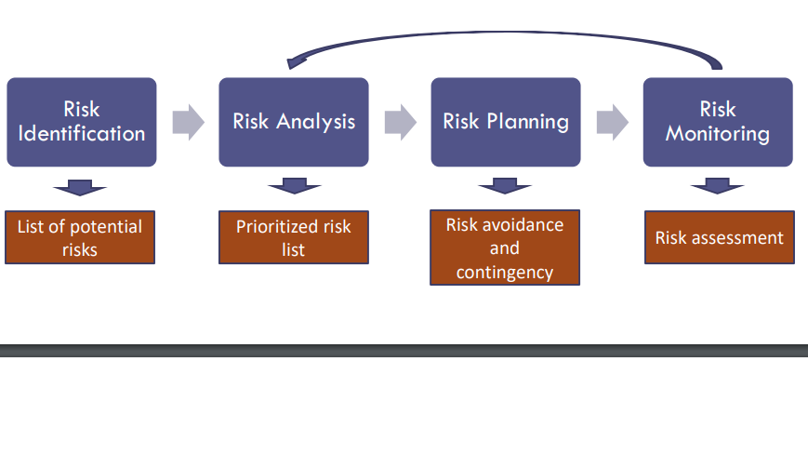

# Deliverables:(Assigned to Sathvik)

| No | Artifact Name | Responsible Party |
| --- | --- | --- |
| 1 | Project Plan | PM |
| 2 | PID Document | PM |
| 3 | BRM Diagram; User roles | Product Owner |
| 4 | Context Diagram; System Interface table | Lead BA |
| 5 | Architecture Diagrams (logical, Process views) | Lead Dev/DBA |
| 6 | Business Requirements | Product Owner |
| 7 | RCT(includes func. decomp, supplementary requests | Lead BA |
| 8 | Use-case Diagrams(UML) | Lead BA |
| 9 | Activity Diagram(UML) | Lead BA |
| 10 | Data-flow Diagrams( Logical, Physical) | Lead BA |
| 11 | Functional Requirements(user stories) | Lead BA |
| 12 | Class Diagram (UML) | Lead Dev |
| 13 | Sequence Diagram (UML) | Lead Dev |
| 14 | ER Diagrams (Conceptual, logical) | DBA |
| 15 | Table Specifications(Data Dictionary) | DBA |
| 16 | Source code sample(Part of Demo) + GIthub repository slides(images) | Lead Dev |
| 17 | Test Plan Document | Lead QA |
| 18 | Application Demo, Presentation PowerPoint | All |

# Stakeholders:(Assigned to Akshay)

| Stakeholder | Interest |
| --- | --- |
| Service/Goods Provider | These are the service providers that use the website to add their services and get reviews on those services. They also provide reviews to the users that used their services. |
| Payment Vendors | The vendors we would use to get the payment processing on the website. |
| Advertising Media | The social media where we will promote our website. |
| Customers | The users use the website to search for the service providers and provide feedback to the service providers on the website. |

# Project Team (Assigned to Lakshmi Bhavani)

The team includes following roles:

* Project Manager
* Product Owner
* Business Analyst
* Lead Developer
* Developer
* DBA
* QA Lead
* Test Manager

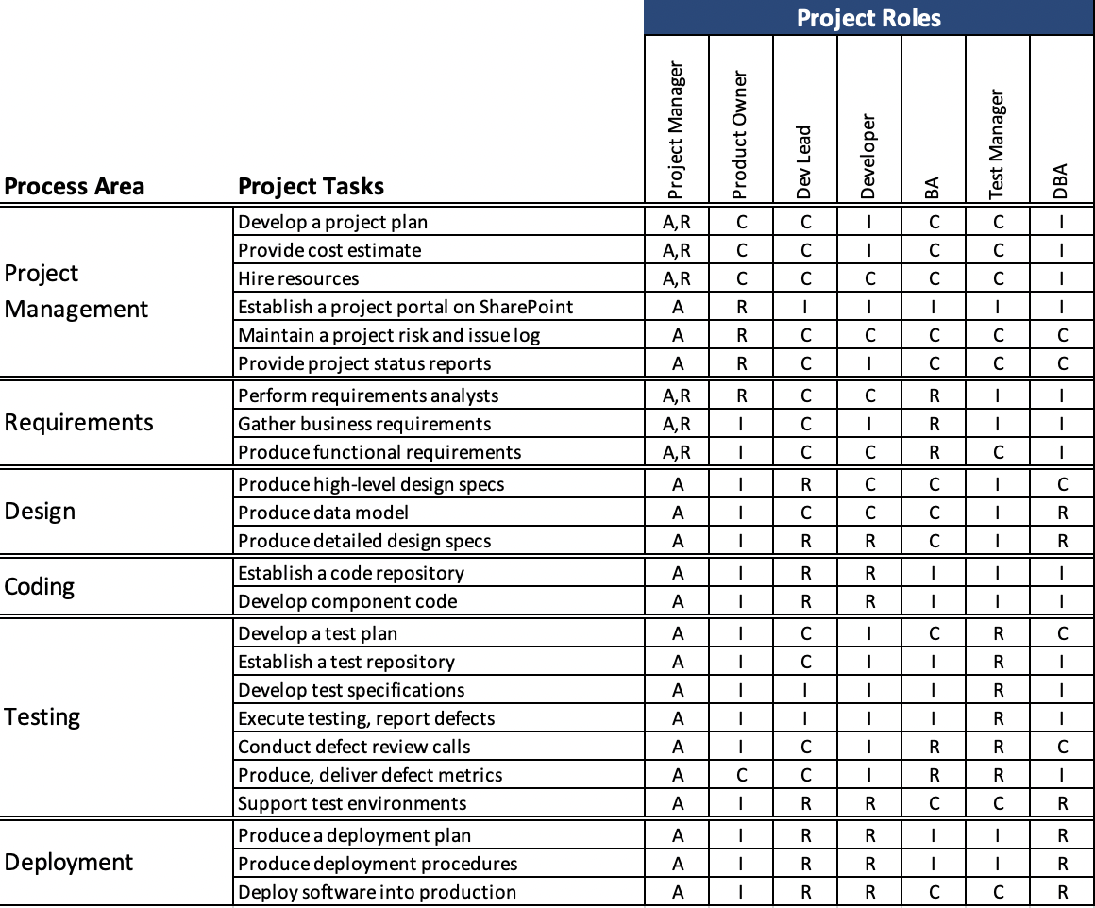

# Project Plan:(Assigned to Shubham)

The project will follow Agile project management methodology. The project will use SCRUM as the development process. Lead developer and developer will be working on background coding. Database developer will work on gathering the data. The Product Owner will mainly be responsible for product management and product quality. The Lead BA and Project Manager will act as Scrum Master. The Quality Analyst and Tester will work on final testing.

There will be few SCRUM sprints. Each sprint will last two weeks. The sprint will start with a sprint planning meeting and will end with a sprint retrospective meeting. Besides the sprint planning meeting and sprint retrospective meeting, there will also be thirty to forty five minutes sprint review virtual meetings every week . Development tool that will be used to supplement SCRUM is Google Sheets. The Agile board will be created in Google Sheets.

Milestones:

MS1: Initial Project Plan (01/25/2022)

MS2: Requirements Completed (03/12/2022)

MS3: Design Completed (03/15/2022)

MS4: Coding Completed (04/12/2022)

MS5: Testing Completed (04/24/2022)

MS6: Project Presentation (05/01/2022)

# Project Controls:(Assigned to Shubham)

# Official language of the project will be english. Official meetings will be held in english. All project documentation and presentations will also be written in english. Project manager will be organizing two weekly meetings. All the team members are allotted their work that has to be completed before each week. In case any member cannot make it to the meeting, the manager should reschedule a meeting or hold it online through zoom meet or google meet. Most of the asynchronous communication will be through zoom meet or google meet. Important points and topics will be discussed in the meetings.Final decisions will be made by the end of the meetings taking everyone’s opinion into consideration.Weekly meeting minutes will be maintained by the project manager which will also include the progress of the project phases. Manager will also keep a track of the deadlines and ensure that everyone plays their role accurately. Slack and Google drive will be used to update all the team members with the important information by the manager and for sharing all the files.

# Communication Plan:(Assigned to Akshay)

| Stakeholder | Frequency | Type | Purpose |
| --- | --- | --- | --- |
| Project Manager | Daily | Email, Skype for Business, personal meetings, phone | To discuss working progress, estimates, requirements prioritization, role and responsibilities within the team. To discuss any issues related to communication between team members or issues related to team members |
| Project Team | Daily | Email, Skype for Business, personal meetings | To discuss working progress, new  requirements, mission or incorrect requirements,defects and their solutions and potential issues |
| End Users | Potentially during the testing phase and after release | Email, online testing sessions | To obtain feedback |
| Quality Management  Team | Daily | Email, Skype for Business | To ensure that all key processes are implemented correctly. |